November 13, 2016
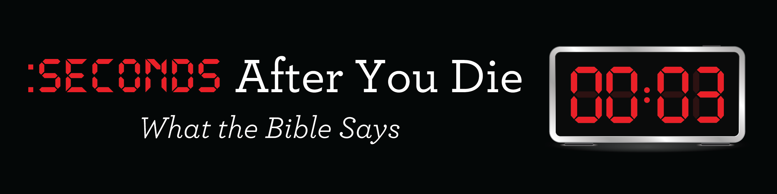

Part 1: Dust to Dust

Discussion: If you could choose the ____________ you would die, what would you choose?

All of us _______________ we are going to die!

“In this world nothing can be said to be certain, except death and taxes.” Benjamin Franklin

“What man can live and not see death?” Psalm 89:48

Have you ever thought about _____________ you might die?

What happens _________________ after you die?

From a ______________ standpoint: Death is the termination of all biological functions that sustain an organism. Wikipedia

“For dust you are and to dust you will return.” Genesis 3:19

“The Lord God formed the man from the dust of the ground and breathed into his nostrils the breath of life, and man became a living being.” Genesis 2:7

From a ________________ standpoint: Death takes place the second your spirit separates from your body.

“The body without the spirit is dead.” James 2:26

“And the dust returns to the ground it came from, and the spirit returns to God who gave it.” Ecclesiastes 12:7

“He took her by the hand and said, ‘My child, get up.’ Her spirit returned, and at once she stood up.” Luke 8:54

“For dust you are and to dust you will return.” Genesis 3:19

Five ________________ you will experience at physical death:

1. _________________.

Romans 8:18-23

2. _________________.

“They are destined for the grave, and death will feed on them… their forms will decay in the grave.” Psalm 49:14

“For when David had served God’s purpose in his own generation, he fell asleep; he was buried with his fathers and his body decayed.” Acts 13:36

Stiff by Mary Roach

“Jesus said, ‘Take away the stone.’ Martha said, ‘But Lord, by this time there is a bad odor, for he has been there four days.’”
John 11:39

3. __________________.

John 19:38-42

Five basic ways we care for our dead in the United States:

1. __________________.

2. __________________.

3. __________________.

4. __________________.

5. __________________.

What does the Bible say about cremation & burial?

Pre-________________________.

Putting My House In Order

Funeral & Cemetery Purchases

4. _________________________.

“It is better to go to a house of mourning than to a house of feasting, for death is the destiny of every man; the loving should take this to heart.” Ecclesiastes 7:2

__________________________!

“Whatever has happened to me has really served to advance the gospel.” Philippians 1:12

“Be very careful, then, how you live—not as unwise but as wise, making the most of every opportunity.” Ephesians 5:15

Six _________________ things to write down now about your celebration service:
- Where do you want to have your service?
- Who do you want to officiate?
- Who would you like to share?
- What is your favorite Scripture?
- What is your favorite song?
- What message do you want communicated?

“Planning your own funeral is a gift from you to your survivors. No one can convey what you wish to leave as a personal testimony better than you.” Billy Graham

The best resource: www.myfamilyorganizer.org for $29.99 online purchase.

5. _____________________.

“We will tell the next generation the praiseworthy deeds of the Lord, his power and wonders he has done.” Psalm 78:4

“Stewardship is not just the tithe we give during our lifetime, but a responsibility which continues after our death.” Billy Graham

“Put your house in order, because you are going to die; you will not recover.” Isaiah 38:1

Two excellent books on the subject of legacy and stewardship:

Nearing Home by Billy Graham

My Footprint For God by Kenn Edwards

“Having your house in order is one of the most important things parents can do for their children. Give them the peace of mind that you have taken care of the business that has come about from your lifetime of labor.” Billy Graham

“It is the responsibility of every believer while they are alive and able to make proper preparations spiritually, as well as fiscally, for the distribution of property and possessions left behind at their death.” Billy Graham

Four legal documents every Christian needs to put in order:

1. Last __________—a legal document that outlines your wishes regarding the distribution of your property and the care of any minor children—it does not eliminate the need for probate court intervention, at a cost.

2. Living _________ or Advance _____________ Care Directive—a legal document that specifies instructions about life support and medical care.

3. Power Of ___________—a legal document that names someone to handle your financial and legal affairs if you can’t.

4. Living ____________—a legal document into which your assets are placed for your benefit while you are alive, but are then transferred to designated beneficiaries at your death—this eliminates probate court.

“Do not store up for yourselves treasures on earth, where moth and rust destroy, and where thieves break in and steal. But store up for yourselves treasures in heaven, where moth and rust do not destroy, and where thieves do not break in and steal.”
Matthew 6:19-20

“Use worldly wealth to gain friends for yourselves, so that when it is gone, you will be welcomed into eternal dwellings.”
Luke 16:9

“A Christian’s will and trust should be a matter of much prayer and thoughtfulness, including gifts not only to individuals but to one’s church and other spiritual organizations.”
Billy Graham

What is in our Family Legacy file?
- 40 Things To Do After A Loved One Dies
- Legal Documents: Will, Living Trust, Health Care Directive, Power of Attorney
- List of Accounts & Passwords
- Income Sources
- Liabilities & Debts
- Insurance: Life, Home & Auto
- Home deeds & Auto titles
- Stocks-Investments
- Business Partnerships
- Birth Certificates & Social Security cards & benefits
- Family Medical Information
- Distribution of Personal Possessions
- Memorial Plans-Mark & Tracy

How do I set up the 4 key legal documents?

Legalzoom.com
Estate Plan Bundle With Attorney Advice
http://www.legalzoom.com/personal/estate-planning/get-your-estate-plan-today.html?page=living-trust

Contact a local attorney that specializes in estate planning services.

“The measure of a life is not its duration but its donation.”
Corrie Ten Boom

He is no fool who gives what he cannot keep to gain what he cannot lose.” Jim Elliot

Discussion: What is the most ________________ thing you have heard today?

“Teach us to number our days aright, that we may gain a heart of wisdom.” Psalm 90:12

Two personal resources:

Estate Planning Attorney: Harry Bruno at hbruno1949@aol.com or 510-581-8701.

Deer Creek Funeral Services: Jay Spencer at www.deercreekcremation.com or 925-934-9000.

